

***“A Community Church in the Foothills”***

***Bill Timm, Pastor***

***Ministers: All of our People***

***Church Phone: 928-342-6002***

***MISSION STATEMENT***

***“WALKING WITH JESUS TO BRING NEW LIFE AND HOPE TO EVERY PERSON”***

**We are a Stephen Ministry Congregation**

SATURDAY, JANUARY 28, 2023 4:00 P.M.

SUNDAY, JANUARY 29, 2023 7:45 A.M & 9:30 A.M.

**FOURTH SUNDAY OF EPIPHANY**



**We welcome you to the worship of this community of faith.**

**As we sing, pray and study God’s word together may we strengthen each other’s faith in the saving power of Jesus Christ. It is difficult to be a Christian by yourself!**

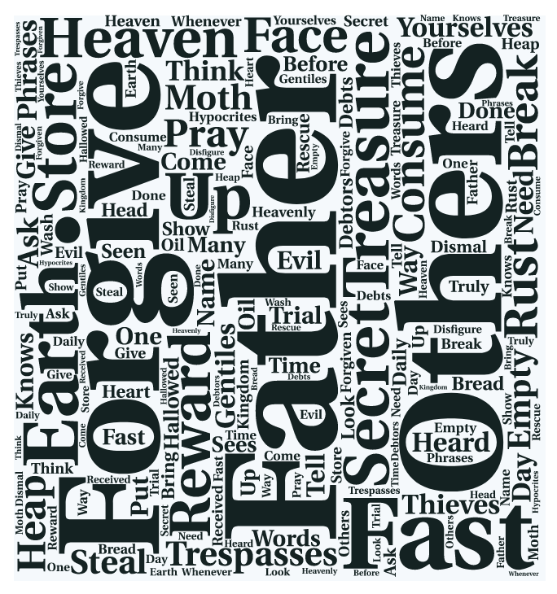

*When you enter this church, it may be possible that you hear “the call of God”. However, it is unlikely that He will call you on your cell phone. Thank you for turning off your phones. If you want to talk to God, enter, choose a quiet place and talk to Him. If you want to see God, send Him a text while driving.*

**VISITORS..** Welcome! Please sign our Guest Book located in the Narthex. Pastor Timm would love to meet you!

**PLEASE REMEMBER…** to contact the church office if you or a loved one are hospitalized, in rehab facility, or facility other than your home. Pastor and Stephen Ministers will make a visit.

**DID YOU KNOW..** Perfume and cologne can trigger life-threatening breathing emergencies in persons with asthma, allergies and chronic obstructive pulmonary disease (COPD) Hospitals and schools are becoming ‘scent-free’ due to this increasing health hazard. Please be sensitive to this concern when coming to church. Thank You.

**LITTLE FOLKS..** Parents… please remember that there are ‘busy bags’ hanging on the coat tree in the Narthex to occupy the little ones during worship. Simply return the bags to the tree on your way out of church. Thank you.

**BE COMFORTABLE..** There are shawls in the Narthex that you can use if chilled during worship. Just ask one of the ushers and they will get you one. Simply return the shawl to the narthex on your way out of the church.

**HEARING DEVICES..** Hearing assist devices are available at the sound booth. The wheel at the top adjusts the volume. When turned on, the light on top should be green. If it is red, please place the device on the counter in the sound booth and take another. Thank you!

**FLOWERS** for the altar today are given to the Glory of God

**MCj03663080000[1]PRAYERS** Geri McDowell (friend of the Glorious Quilters), Diane Urrey, Sharon Ruble (aunt of Niki Duffy), Linda Helland (friend of Sandra Black), Shar Stapleton, Robert Zuhr (brother of Brigitte Arnio), Mason Fletcher(friend of the Duffy’s), Sally Holdsworth, Joanne Munson, Lissi Grill, David Radke (son Dyanne Radke), Mickey Wilson (friend of Sandy Weidling), Bonnie Rothi, Alyce Waverly.

*Please keep in your prayers the family and friends of Bev Gedde, she went to be with the Lord on Monday morning.*

*Prayers for all military personnel serving around the world.*

*(we do not publish the names for the safety of the service members and their families.).*

***PLEASE NOTE that we’ll be using the contemporary version of the Lord’s Prayer for the month of January. God blesses our prayers.***

**PRELUDE**

**ANNOUNCEMENTS**

P God Is Good!

**C All the time**

P All the time

**C God Is Good!**

**CONFESSION AND FORGIVENESS**

PBlessed be the Holy Trinity, ☩ one God, full of compassion and mercy, abounding in steadfast love.

**C Amen.**

P Trusting God’s promise of forgiveness, let us silently confess our sin against God and one another.

*Pause for silence and reflection.*

P Merciful God,

**C Christ came into the world and showed us how to live, but we have failed to live by what he taught. We have not loved you with all our heart, soul, mind and strength, we have not done to others as we would have done to ourselves. Shine a light on our hearts, that we might turn from the shadows of our sin and walk in your ways.**

P In the mercy of almighty God, Jesus Christ was given to die for us, and for his sake God forgives us all our sins. To those who believe in Jesus Christ he gives the power to become the children of God and bestows on us the Holy Spirit. **Amen.**

**GATHERING HYMN** “Bright and Glorious Is the Sky” ELW 301

**GREETING**

PThe grace of our Lord Jesus Christ, the love of God, and the communion of the Holy Spirit be with you all.

**C And also with you.**

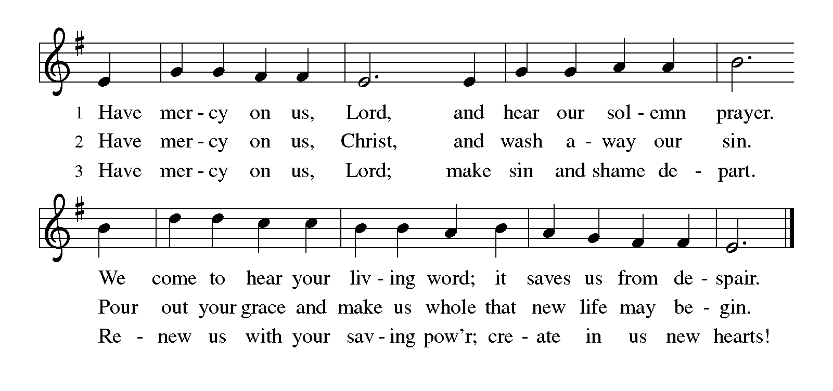**KYRIE**

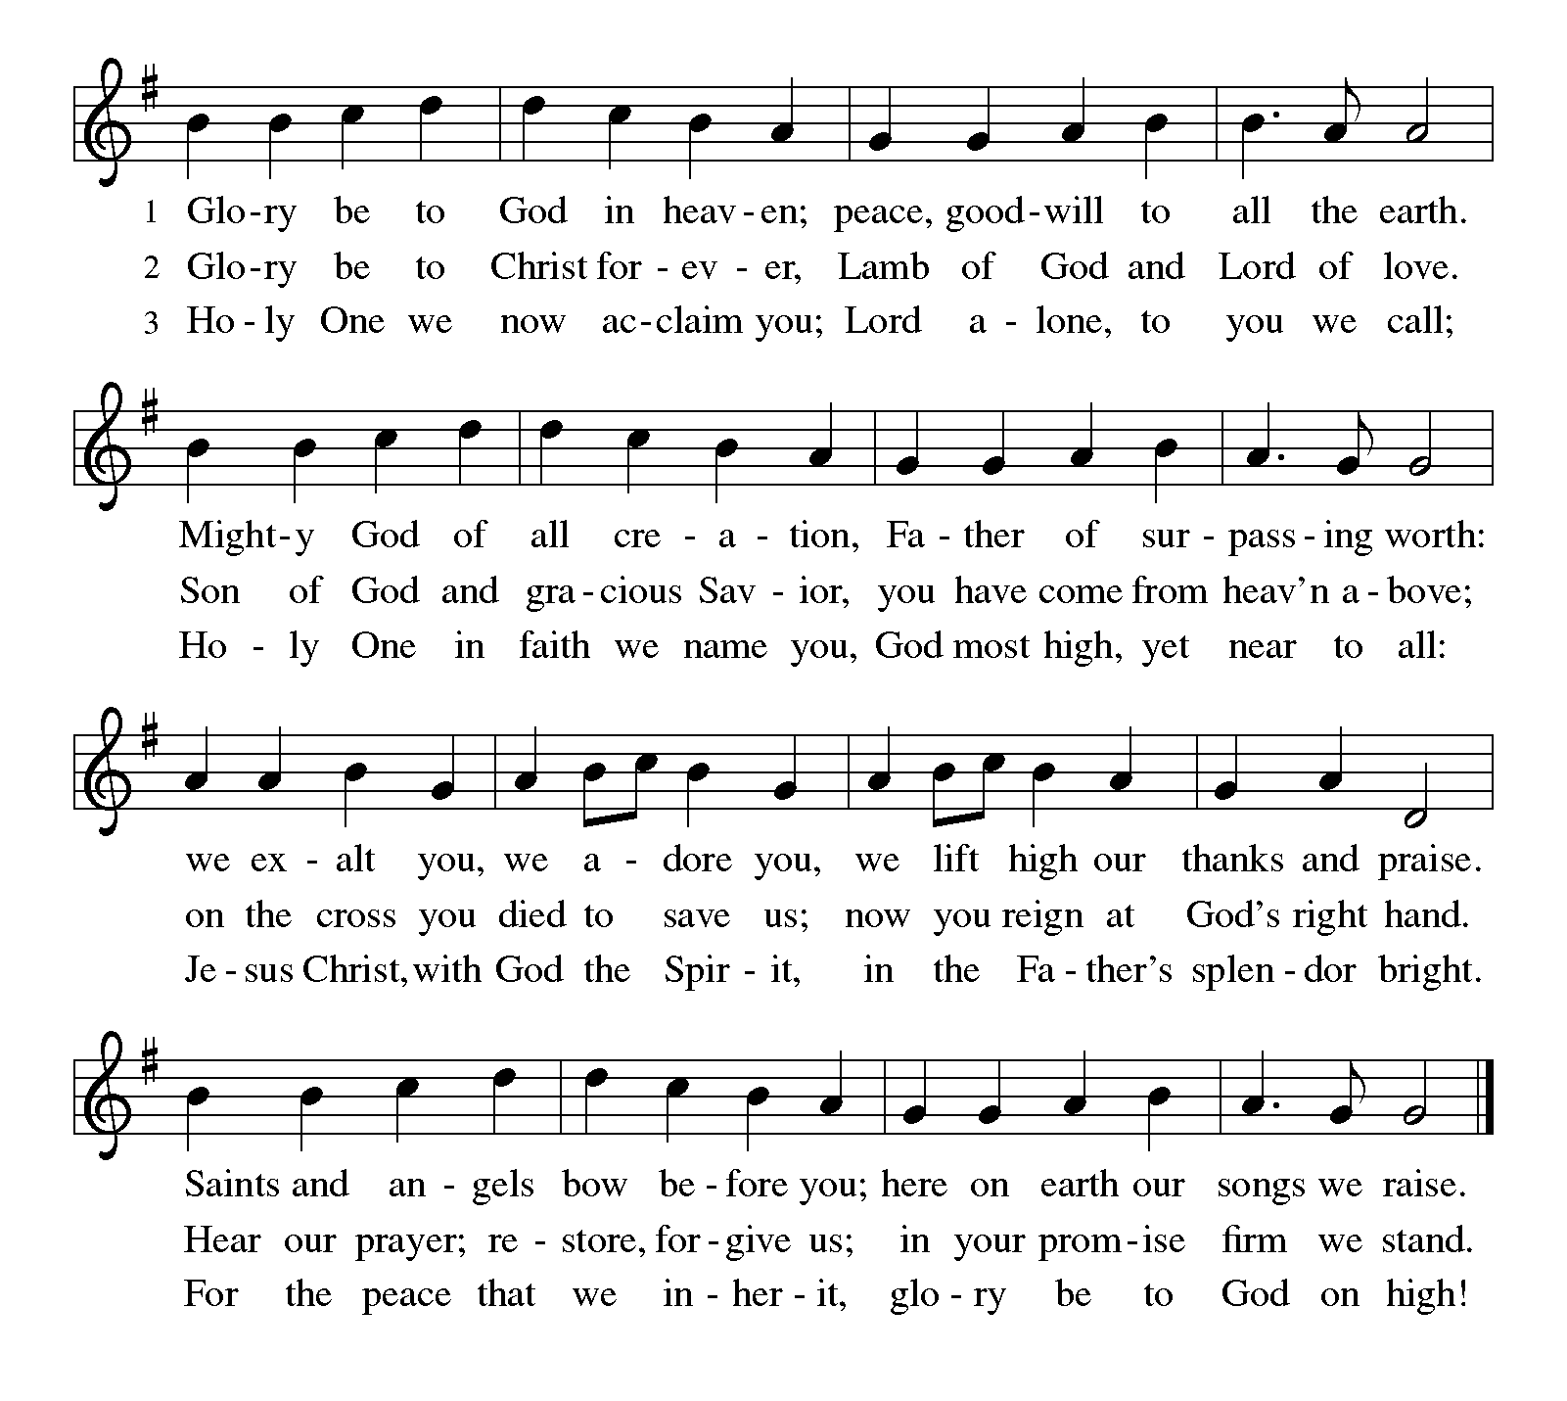**SONG OF PRAISE**

**PRAYer of the Day *together we pray:***

**C Gracious God, You invite us to come to you in prayer, and offer us a promise of your never-ending care. Give us the humility to ask only for what we need and to be grateful when we receive it, for the sake of Jesus Christ our Lord and Savior who lives and reigns with you and the Holy Spirit, one God, now and forever. Amen**

**PASSING OF THE PEACE**

PThe peace of the Lord be with you

**C And also with you**

**WORSHIP CAROL-**

**Bells of Glory**  “Praise and Thanksgiving” 4:00 pm

**Bells of Glory** “Foundatio****n” 7:45 am **Choir**  “Bless His Holy Name” 9:30 am

**PSALM 20: 1-9 Read Responsively**

R**1**The Lord answer you in the day of trouble!  
    The name of the God of Jacob protect you!  
**C 2May he send you help from the sanctuary  
    and give you support from Zion.**R **3**May he remember all your offerings  
    and regard with favor your burnt sacrifices.

**C 4May he grant you your heart’s desire  
    and fulfill all your plans.**

R **5**May we shout for joy over your victory  
    and in the name of our God set up our banners.  
May the Lord fulfill all your petitions.

**C 6Now I know that the Lord will help his anointed;  
    he will answer him from his holy heaven  
    with mighty victories by his right hand.**R **7**Some take pride in chariots and some in horses,  
    but our pride is in the name of the Lord our God.  
**C 8They will collapse and fall,  
    but we shall rise and stand upright.**

R **9**Give victory to the king, O Lord;  
    answer us when we call.[[a](https://www.biblegateway.com/passage/?search=PSALM+20%3A+1-9&version=NRSVUE#fen-NRSVUE-14192a)]

**GOSPEL ACCLAMATION** 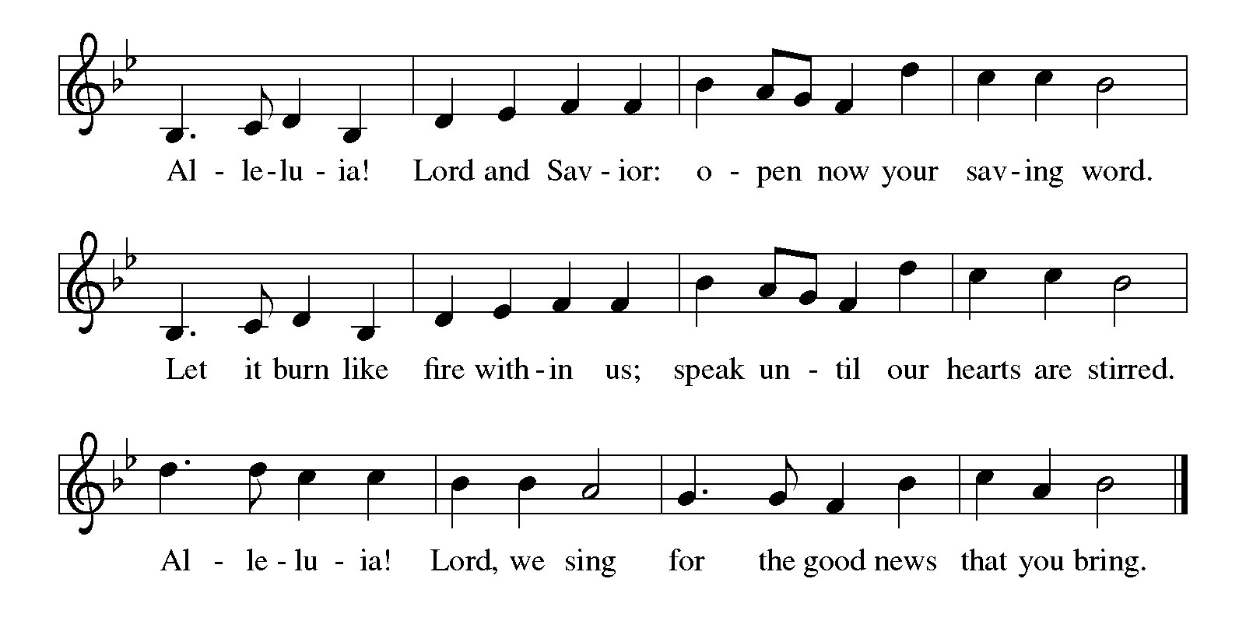

**GOSPEL: MATTHEW 6: 7-21; 25-34**

**7**“When you are praying, do not heap up empty phrases as the gentiles do, for they think that they will be heard because of their many words. **8**Do not be like them, for your Father knows what you need before you ask him.

**9**“Pray, then, in this way:

Our Father in heaven,  
    may your name be revered as holy.  
**10**    May your kingdom come.  
    May your will be done  
        on earth as it is in heaven.  
**11**    Give us today our daily bread.[[a](https://www.biblegateway.com/passage/?search=MATTHEW+6%3A+7-21%3B+25-34&version=NRSVUE#fen-NRSVUE-23294a)]  
**12**    And forgive us our debts,  
        as we also have forgiven our debtors.  
**13**    And do not bring us to the time of trial,[[b](https://www.biblegateway.com/passage/?search=MATTHEW+6%3A+7-21%3B+25-34&version=NRSVUE#fen-NRSVUE-23296b)]  
        but rescue us from the evil one.[[c](https://www.biblegateway.com/passage/?search=MATTHEW+6%3A+7-21%3B+25-34&version=NRSVUE#fen-NRSVUE-23296c)]

**14**“For if you forgive others their trespasses, your heavenly Father will also forgive you, **15**but if you do not forgive others,[[d](https://www.biblegateway.com/passage/?search=MATTHEW+6%3A+7-21%3B+25-34&version=NRSVUE#fen-NRSVUE-23298d)] neither will your Father forgive your trespasses.

**16**“And whenever you fast, do not look somber, like the hypocrites, for they mark their faces to show others that they are fasting. Truly I tell you, they have received their reward. **17**But when you fast, put oil on your head and wash your face, **18**so that your fasting may be seen not by others but by your Father who is in secret, and your Father who sees in secret will reward you.[[e](https://www.biblegateway.com/passage/?search=MATTHEW+6%3A+7-21%3B+25-34&version=NRSVUE#fen-NRSVUE-23301e)]

**19**“Do not store up for yourselves treasures on earth, where moth and rust[[f](https://www.biblegateway.com/passage/?search=MATTHEW+6%3A+7-21%3B+25-34&version=NRSVUE#fen-NRSVUE-23302f)] consume and where thieves break in and steal, **20**but store up for yourselves treasures in heaven, where neither moth nor rust[[g](https://www.biblegateway.com/passage/?search=MATTHEW+6%3A+7-21%3B+25-34&version=NRSVUE#fen-NRSVUE-23303g)] consumes and where thieves do not break in and steal. **21**For where your treasure is, there your heart will be also.

**25**“Therefore I tell you, do not worry about your life, what you will eat or what you will drink,[[a](https://www.biblegateway.com/passage/?search=MATTHEW+6%3A+7-21%3B+25-34&version=NRSVUE#fen-NRSVUE-23308a)] or about your body, what you will wear. Is not life more than food and the body more than clothing? **26**Look at the birds of the air: they neither sow nor reap nor gather into barns, and yet your heavenly Father feeds them. Are you not of more value than they? **27**And which of you by worrying can add a single hour to your span of life?[[b](https://www.biblegateway.com/passage/?search=MATTHEW+6%3A+7-21%3B+25-34&version=NRSVUE#fen-NRSVUE-23310b)] **28**And why do you worry about clothing? Consider the lilies of the field, how they grow; they neither toil nor spin, **29**yet I tell you, even Solomon in all his glory was not clothed like one of these. **30**But if God so clothes the grass of the field, which is alive today and tomorrow is thrown into the oven, will he not much more clothe you—you of little faith?

**31**Therefore do not worry, saying, ‘What will we eat?’ or ‘What will we drink?’ or ‘What will we wear?’ **32**For it is the gentiles who seek all these things, and indeed your heavenly Father knows that you need all these things. **33**But seek first the kingdom of God[[c](https://www.biblegateway.com/passage/?search=MATTHEW+6%3A+7-21%3B+25-34&version=NRSVUE#fen-NRSVUE-23316c)] and his[[d](https://www.biblegateway.com/passage/?search=MATTHEW+6%3A+7-21%3B+25-34&version=NRSVUE#fen-NRSVUE-23316d)] righteousness, and all these things will be given to you as well.

**34**“So do not worry about tomorrow, for tomorrow will bring worries of its own. Today’s trouble is enough for today.

P The Gospel of the Lord   
**C Praise to the Lord**   
 **TEACHING**  *“*O GOOD LORD???!!!*”* Pastor Bill Timm

**HYMN OF THE DAY:** “My Faith Looks Up to Thee” ELW 759

**THE APOSTLES’ CREED**

**I believe in God, the Father almighty,**

**creator of heaven and earth.**

**I believe in Jesus Christ, His only Son, our Lord.**

**He was conceived by the power of the Holy Spirit**

**and born of the virgin Mary.**

**He suffered under Pontius Pilate,**

**was crucified, died, and was buried.**

**He descended into hell.**

**On the third day He rose again.**

**He ascended into heaven,**

**and is seated at the right hand of the Father.**

**He will come again to judge the living and the dead.**

**I believe in the Holy Spirit,**

**the holy catholic Church,**

**the communion of saints,**

**the forgiveness of sins,**

**the resurrection of the body,**

**and the life everlasting. Amen.**

**PRAYERS OF INTERCESSION**

PWe pray for the church, the world, and all those in need.

*A brief silence.*

P God of abundance, your son, Jesus, showed us how to pray so that the blessings of heaven might be ours. Keep us ever mindful of those things which are of true and lasting value. Merciful God,

**C Hear our prayer.**

P Let the earth heal from the thoughtless damage we have done to it. Make us passionate stewards of your creation, working diligently for its nurture rather than its destruction. Merciful God,

**C Hear our prayer.**

P Bless our world’s religious leaders, and encourage them to be models of faithful living for their communities of faith. Merciful God,

**C Hear our prayer.**

P Place your healing hands upon all who are in need, those who are grieving, incarcerated, addicted, isolated, neglected, abused, or ill. Merciful God,

**C Hear our prayer.**

P Inspire us to share out of our abundance with those who suffer poverty. Commit us to ensuring that all people have what they need to flourish. Merciful God,

**C Hear our prayer.**

*Here other petitions may be offered. Together we pray*

**C We pray for all of our mission congregations, local partners and for all of our care ministries, We also pray for the congregation’s vision process, may we continue to work toward our mission and uphold our values. For God to enlarge our hearts toward people far from God; and to Walk with Jesus to bring new life and hope to every person.**

P We lovingly remember all the saints whose lives have taught us to store up treasures in heaven. Keep them in your care until the day we all see you together. Merciful God,

**C Hear our prayer.**

P Receive our prayers and hold all for whom we pray in your loving arms, in the name of your son, Jesus Christ. **Amen**.

**THE OFFERING** (For those watching there is a link for online giving in the description of the video. We are thankful for all the support from both in person giving as well and online giving. **You will find directions in the pew for our Text-giving option**)

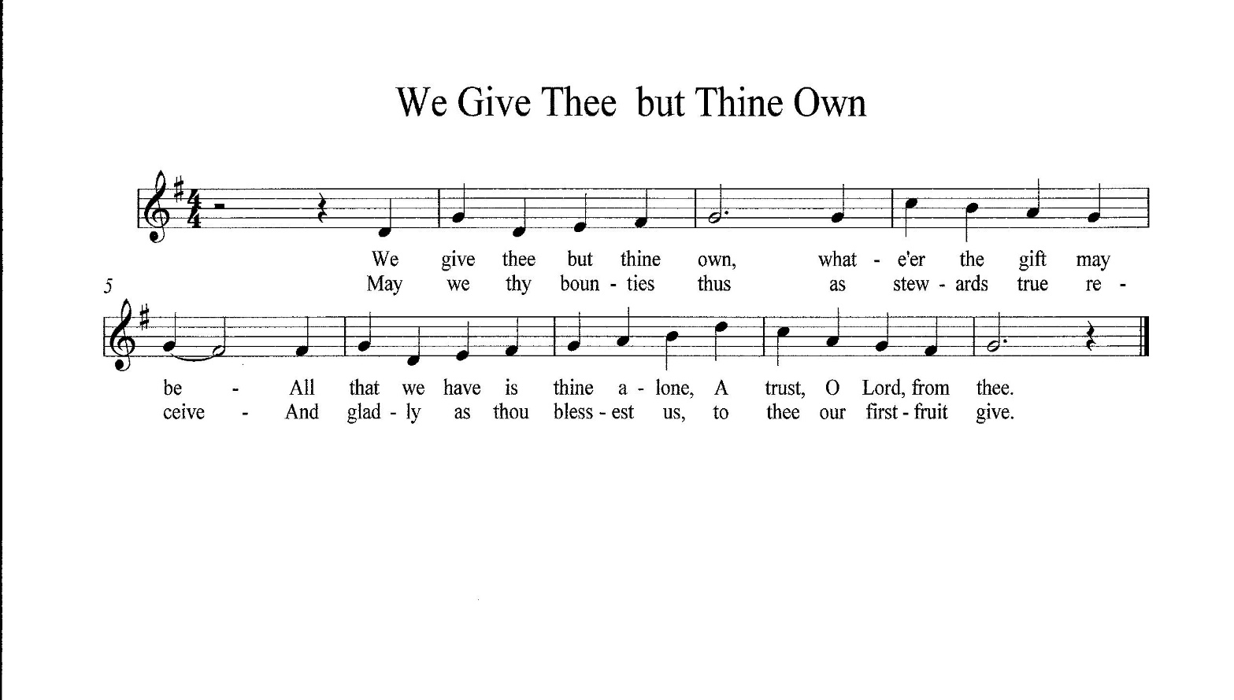**OFFERING RESPONSE** *(please stand)*

**THE GREAT THANKSGIVING**

**P** The Lord be with you.

**C And also with you.**

**P** Lift up your hearts.

**C We lift them to the Lord.**

**P** Let us give thanks to the Lord our God.

**C It is right to give our thanks and praise.**

**CONGREGATIONAL SUNG RESPONSE**

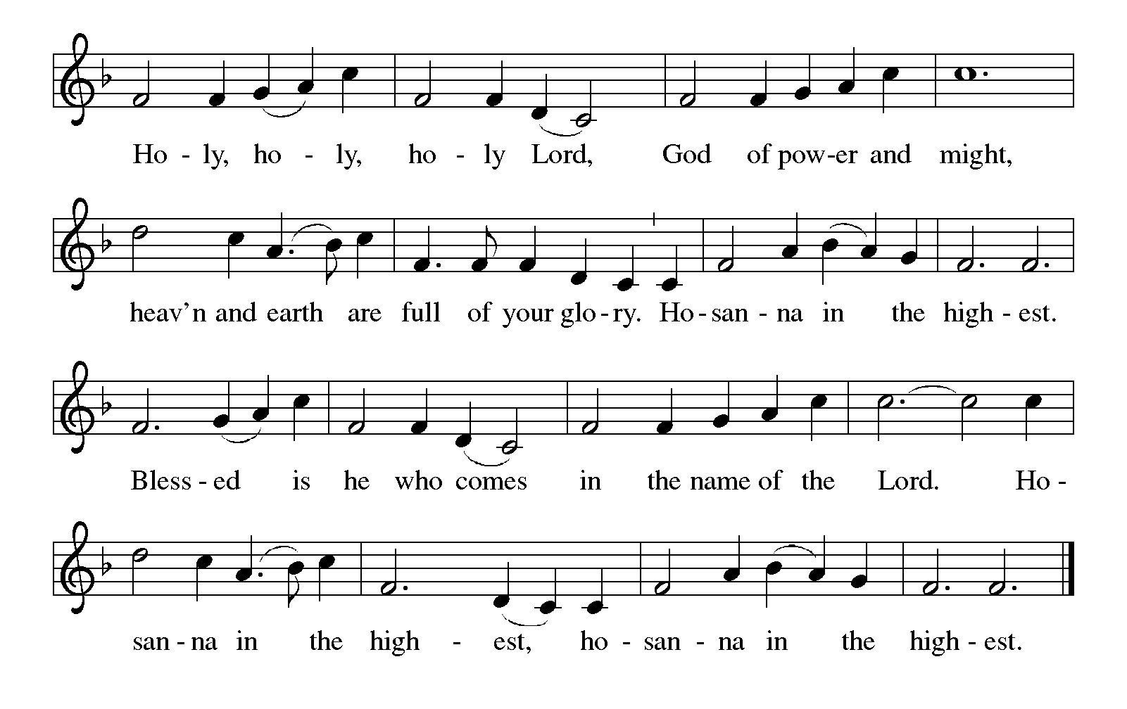

P Blessed are you, Lord of heaven and earth.  In mercy for our fallen world, you gave your only Son, that all those who believe in him should not perish, but have eternal life.

We give thanks to you for the salvation you have prepared for us through Jesus Christ.

Send now your Holy Spirit into our hearts, that we may receive our Lord with a living faith as he comes to us in his holy supper.

**C  Amen.  Come, Lord Jesus.**

**THE SACRAMENT OF HOLY COMMUNION**

**WORDS OF INSTITUTION**

Communion is open to all baptized believers who know Jesus as Savior and seek to live with him as Lord of all areas of life. You receive the wafer in your hand and choose from the individual cup of wine or white grape juice. Those who do not commune and children may come forward for a blessing, simply cross your arms in front of your chest to request a blessing. Simply complete a slip found in the pew rack and place it in the offering plate. Consider the options on reverse side as to how you may serve this congregation.

**THE LORD’S PRAYER**

**C Our Father in heaven, hallowed be your name, Your kingdom come, Your will be done, on earth as in heaven. Give us today our daily bread. Forgive us our sins as we forgive those who sin against us. Save us from the time of trial and deliver us from evil. For the kingdom, the power, and the glory are yours, now and forever. Amen.**

**HYMNS DURING COMMUNION**

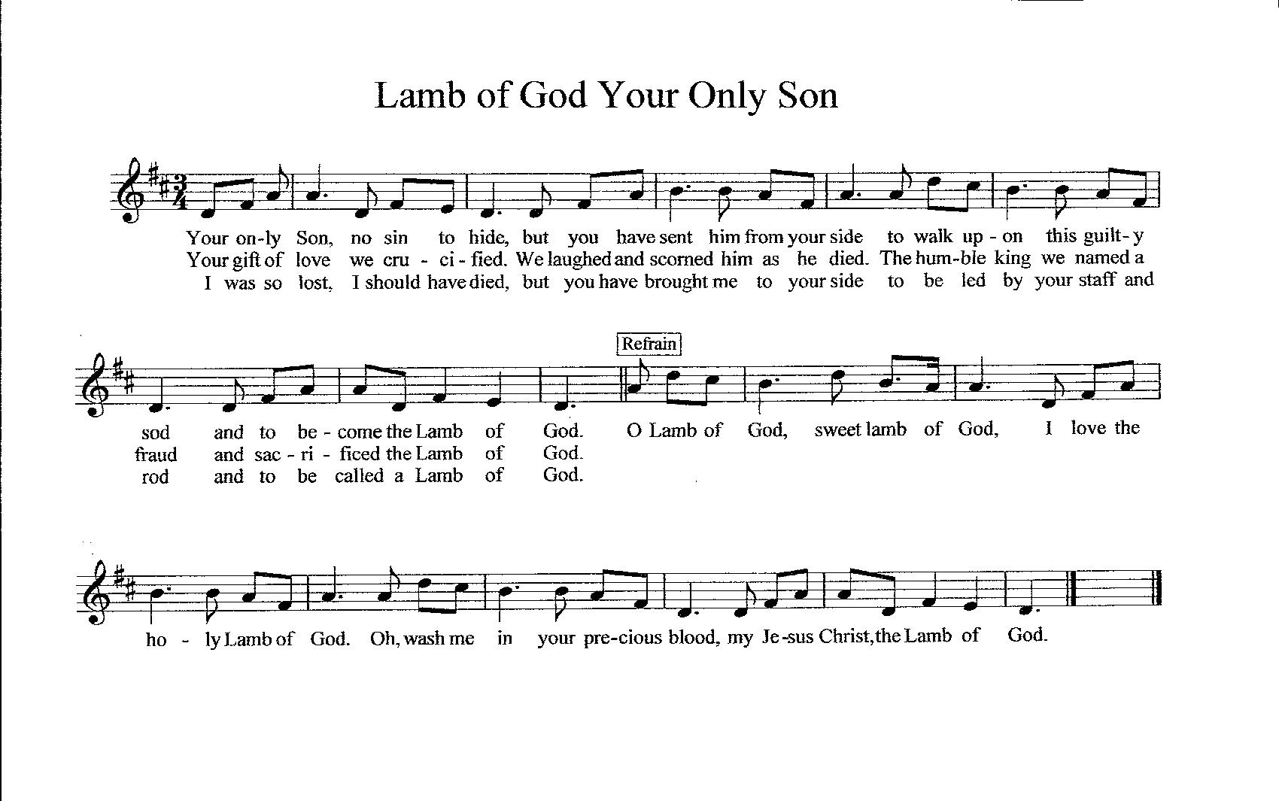

**HYMNS DURING COMMUNION**

“Faith of Our Fathers” ELW 812

“Now Thank We All Our God” ELW 840

“Come, Let Us Join Our Cheerful Songs” ELW 847

**POST COMMUNION BLESSING** *(please stand)*

PThe Body and Blood of our Lord and Savior Jesus Christ strengthen you and keep you safe in His Grace until everlasting life.

**C Amen.**

**PRAYER AFTER COMMUNION**

**C Living God, you have greeted us in our brokenness and nourished us with the body of Christ, broken for us. Risen to new life with you, send us now to bear your healing love into the wounded world, in the name of our risen Savior and Lord. Amen**

**SENDING HYMN**“O Master, Let Me Walk with You” ELW 818

**BENEDICTION**

P    Almighty God has created you and has a purpose for your life every day! Lord, Help us remember, IF YOU ARE NOT DEAD...

**C    YOU ARE NOT DONE!**

PLive your lives in Christ, rooted and built up in him, and abound in thanksgiving; and the blessing of the Holy Trinity, ☩ one God, be upon you and remain with you forever.

**C Amen.**

**Dismissal**

P Go in peace. Christ is sending you.

**C Thanks be to God.**

Sundays and Seasons.com Copyright 2008 Augsburg Fortress. All rights reserved. Reprinted by permission under Augsburg Fortress Liturgies Annual License #26302.

New Revised Standard Version Bible, copyright 1989, Division of Christian Education of the National Council of the Churches of Christ in the United States of America. Used by permission. All rights reserved.

Reprinted from *Lutheran Book of Worship,* copyright 1978 or reprinted from Service book and Hymnal, copyright 1958. Used by permission of Augsburg Fortress license #11751-L.

Reprinted from *Evangelical Lutheran Worship,* copyright 2006 Augsburg Fortress. Used by permission of Augsburg Fortress license #11752-E.

Cover page – Reprinted from *Icon Two: Visual Images for Every Sunday,* copyright 2004 Augsburg Fortress. Used by permission

CCLI Song #1527, Majesty, Hayford, Jack, copyright 1981, New Spring. For use solely with the SongSelect . Terms of Use. All rights reserved. CCLI License #132196

Faith Stepping Stones, Copyright © 1998 Faith Inkubators Project, www.faithink.com.

***WORSHIP ASSISTANTS***

|  |  |  |  |  |  |
| --- | --- | --- | --- | --- | --- |
| **Date** | **Time** | **Altar** | **Ushers** | **Greeter/Communion Assistants** | **Readers** |
| 1/28 | 4:00pm | Doreen | Stan/Ila Goter | Janis Suess/  Char | Sandy Weidling |
| 1/29 | 7:45am | Char | Mary Marsh/  Yvonne Wurtele | Larry Unger/  Cheryl Preul | Char |
| 1/29 | 9:30am | Niki | Mike/Sandy Corless | Ted/Niki Duffy | Jim Hollandsworth |
|  |  |  |  |  |  |
| 2/4 | 4:00pm | Kris | Dave/Marge Graham | Mary Marsh/Char | Jeanie Volpe |
| 2/5 | 7:45am | Nancy | Dave/Nancy Griffiths | John/Sharon Merz | Nancy Griffiths |
| 2/5 | 9:30am | Doreen | Jim/Linda Bryant | Sue Martin/  Michelle Cegon | Jerry Randby |
|  |  |  |  |  |  |
| 2/11 | 4:00pm | Joanne | Marge Jones/  S. Noltemeyer | Linda Kasin/  Doreen Caldwell | Linda Kasin |
| 2/12 | 7:45am | Char | Dave/Nancy Griffiths | Brenda Taylor/  Char | Char Schomisch |
| 2/12 | 9:30am | Niki | Randy/Mary Zieman | Jerry Taylor/  Diane Lee | Jerry Taylor |

***Attendance last week January 22th***

***77 at 4pm; 49 at 7:45 am; 152 at 9:30am-***

***total in person=278***

***9 views on Youtube and 113 views on Facebook.***

***total online =122***

***CALENDAR FOR THE COMING WEEK***

|  |  |  |  |
| --- | --- | --- | --- |
| **DATE** | **TIME** | **ACTIVITY** | **LOCATION** |
| Sunday 1/29 | 11:00 am | ANNUAL MEETING | Fellowship Hall |
| Sunday 1/29 | 1:00 pm | Foothills Social | Fellowship Hall |
| Sunday 1/29 | 1:30 pm | GriefShare | Fellowship Classroom |
|  |  |  |  |
| Monday 1/30 | 9:00 am | Glorious Quilters | Fellowship Hall |
| Monday 1/30 | 10:00 am | GriefShare | Fellowship Classroom |
| Monday 1/30 | 12:30 pm | Bible Study | Fellowship Classroom |
| Tuesday 1/31 | 7:00 am | TOPS | Fellowship Hall |
| Tuesday 1/31 | 10:00 am | Bible Study | ZOOM |
| Tuesday 1/31 | 1:00 pm | Foothills Social | Fellowship Hall |
| Wednesday 2/1 | 8:30 am | Stephen Ministry Training | Fellowship Classroom |
| Wednesday 2/1 | 4:45 pm | Bells of Glory Practice | Sanctuary |
| Wednesday 2/1 | 6:00 pm | Choir Practice | Sanctuary |
| Thursday 2/2 | 7:00 am | TOPS | Fellowship Hall |
| Thursday 2/2 | 1:00 pm | Worship Matters Class | Sanctuary |
| Thursday 2/2 | 5:00 pm | TOPS | Fellowship Classroom |
| Friday 2/3 | 8:00 am | TOPS | Fellowship Hall |
| Friday 2/3 | 1:00 pm | Foothills Social | Fellowship Hall |
| Friday 2/3 | 6:00 pm | Women’s AA | Fellowship Hall |
|  |  |  |  |
| Saturday 2/4 | 8:00 am | Men’s Breakfast | DayBreakers |
| Saturday 2/4 | 4:00 pm | Worship/Communion | Sanctuary |
| Sunday 2/5 | 7:45 am | Worship/Communion | Sanctuary |
| Sunday 2/5 | 9:30 am | Worship/Communion | Sanctuary |
| Sunday 2/5 | 1:30 pm | GriefShare | Fellowship Classroom |

**Pastor’s Bible Study on the Gospel of Matthew**

**Mondays at 12:30pm in the Fellowship Hall Classroom**

**Zoom Bible Study will be Tuesdays at 10am**

***If you need assistance getting on zoom, please call Kate in the office.***

***Announcements***

**Annual Meeting-** Will be on Sunday, January 29th. Lunch will be served at 10:30 am and meeting will start at 11am.

**Yard Sale-** There is a yard sale meeting next Thursday February 9th at 1:00 pm. Dates for the yard sale this year are Friday February 24th and Saturday February 25th. Donations will be accepted starting Tuesday February 21st.

**Book sale-**  Book Sale dates for this year are March 10th and 11th, donations are now being accepted during office hours only.

**LENT-** Join us for this year’s Lenten Series **“The Seven Last Words of Jesus”**Ash Wednesday, February 22, 2023, **Father Forgive Them For They Know Not What They Do** Roger Tracey  
Wednesday, March 1st, **Today You Will Be With Me In Paradise,** Randy Zieman   
Wednesday, March 8th, **Here is your Son, Here is Your Mother** , Char Schomisch  
Wednesday, March 15th,**My God, My God, Why Have You Forsaken Me?** , Jerry Randby   
Wednesday, March 22nd, **I Thirst**, Shirley Ehler  
Wednesday, March 29th, **It Is Finished** , Michelle Cegon

**Dinner Theater –** Beginning next weekend tickets for the dinner theater (a hilarious comedy) will be available for purchase. The dates are February 16, 17 & 18th. Cost is $15.00/person. Dinner served at 5:30 with the play at 6:00 pm. Only 50 tickets/night will be sold so get yours right away.

**GLORIA DE CRISTO LUTHERAN CHURCH**

**11273 E. 40th Street**

**Yuma, AZ 85367**

Phone:(928) 342-6002 Fax (928) 342-7613

Website: [www.gloriadecristo.com](http://www.gloriadecristo.com)

Pastor: William Timm ([BillTimm03@outlook.com](mailto:BillTimm03@outlook.com))  
Minister of Worship, Organist & Choir Director: Dr. Shirley Ehler ([scehler@gmail.com](mailto:scehler@gmail.com))   
Pianists: Jean Abel, Sue Bridie, Marie Ritten

Bells of Glory: Kay Lee Grunst ([kleeg59@outlook.com](mailto:kleeg59@outlook.com))

Acolytes: Aiden Harwood & Oakley Johnson

GriefShare Group Leaders:

Ted & Niki Duffy

Mary Marsh

Stephen Ministry Leaders:

Michelle Cegon ([jdcmom1963@hotmail.com](mailto:jdcmom1963@hotmail.com))

Pastor Timm ([BillTimm03@outlook.com](mailto:BillTimm03@outlook.com))

Jim Wehrer ([jim.wehrer@gmail.com](mailto:jim.wehrer@gmail.com))

Sherrie Wehrer ([slewis1959@gmail.com](mailto:slewis1959@gmail.com))

Office Staff:

Kate Harwood, Secretary ([kategdc@outlook.com](mailto:kategdc@outlook.com))

Brennen Harwood, A/V Technician

CPA Financial Advantage, Payroll

**Follow us on Facebook and subscribe to our YouTube channel**

**Links to both pages can be found on our website**