
Aa

“A Community Church in the Foothills”

Ministers: All of our People
Church Phone: 928-342-6002

MISSION STATEMENT

“WALKING WITH JESUS TO BRING NEW LIFE AND HOPE TO EVERY PERSON”

We are a Stephen Ministry Congregation

FOURTH SUNDAY OF EASTER
SUNDAY, MAY 11, 2025 8:30 A.M.
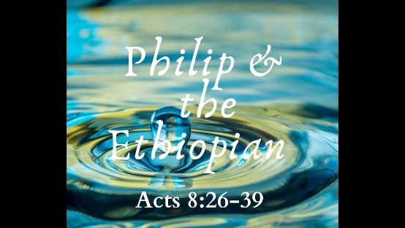

We welcome you to the worship of this community of faith.
As we sing, pray and study God’s word together may we strengthen each other’s faith in the saving power of Jesus Christ. It is difficult to be a Christian by yourself!

When you enter this church, it may be possible that you hear “the call of God”. However, it is unlikely that He will call you on your cell phone. Thank you for turning off your phones. If you want to talk to God, enter, choose a quiet place and talk to Him. If you want to see God, send Him a text while driving.

VISITORS.. Welcome! Please sign our Guest Book located in the Narthex. We would love to meet you!

PLEASE REMEMBER… to contact the church office if you or a loved one are hospitalized, in rehab facility, or facility other than your home. Pastor and Stephen Ministers will make a visit.

DID YOU KNOW.. Perfume and cologne can trigger life-threatening breathing emergencies in persons with asthma, allergies and chronic obstructive pulmonary disease (COPD) Hospitals and schools are becoming ‘scent-free’ due to this increasing health hazard. Please be sensitive to this concern when coming to church. Thank You.

LITTLE FOLKS.. Parents… please remember that there are ‘busy bags’ hanging on the coat tree in the Narthex to occupy the little ones during worship. Simply return the bags to the tree on your way out of church. Thank you.

BE COMFORTABLE.. There are shawls in the Narthex that you can use if chilled during worship. Just ask one of the ushers and they will get you one. Simply return the shawl to the narthex on your way out of the church.

Hearing Devices: The older hearing devices have been moved to the Narthex. They are located next to the far right entrance door to the sanctuary.

We now offer the T-Coil hearing device with the new sound system. Individuals will need to contact their provider to find out if their hearing aid is telecoil-equipped. If so, they need to ask how to turn on the T-Coil or if it is automatically linked once the loop is around their neck.

FLOWERS for the altar today are given by Shirley Johnson in memory of husband Durell, and Jerry & Chris Randby in celebration of their 48th wedding anniversary.

PRAYERS: Dyanne Radke, Bill Timm, Mary Marsh, Robin Marlatt, Nancy Griffiths, Bill Haney, Mike Corless, Dick Sowers (friend of Gary Raasch), Benny Bennight & Pastor Lee Bennight (friends of Sharon Merz), Dave Blevins (friend of Gary Raasch), Schmidt Family (friends of Lorie Rapp), Jacky Patte, Janice Radke (Dyanne Radke’s daughter-in-law), Donna (sister of Lisa Crayne), Loretta Munsterman, Susie Reible, Susan Baxter, Mason Fletcher (Grandson of Lisa Crayne), Glennis Swain (friend of Jim & Sherrie Wehrer), Forrest Marsh, Carolyn Smith, Rita (sister of Marlene Miller)

Remember in your prayers Sandy Corless and Family. Mike went to be with his Lord on Thursday, May 8, 2025.

PLEASE NOTE that we’ll be using the Traditional version of the Lord’s Prayer for the month of May. God blesses our prayers.

Is Your Phone Turned Off?

PRELUDE

ANNOUNCEMENTS

V God Is Good!
C All the time
V All the time
C God Is Good!

CONFESSION AND FORGIVENESS

V Blessed be the Holy Trinity, ☩ one God, full of compassion and mercy, abounding in steadfast love.

C Amen.

V We confess our sins before God and one another.

Pause for silence and reflection.
V God of light,
C We live as though you are still in the grave. We do not rejoice in the good news of liberation for all people without exception. We continue to sin against you and our neighbors by our actions and our failure to act. Shake us out of our complacency, cleanse our hearts of selfishness, and make us joyful participants in the work of bringing about your reign in the world today.

V We are an Easter people! Through the death and resurrection of Jesus Christ, God has redeemed all of creation. Know that you are made whole, forgiven of all your sins, and empowered to live out the gospel in joy.

C Amen.

GATHERING HYMN “Beautiful Savior ” ELW 838

GREETING

V The grace of our Lord Jesus Christ, the love of God, and the communion of the Holy Spirit be with you all.

C And also with you.

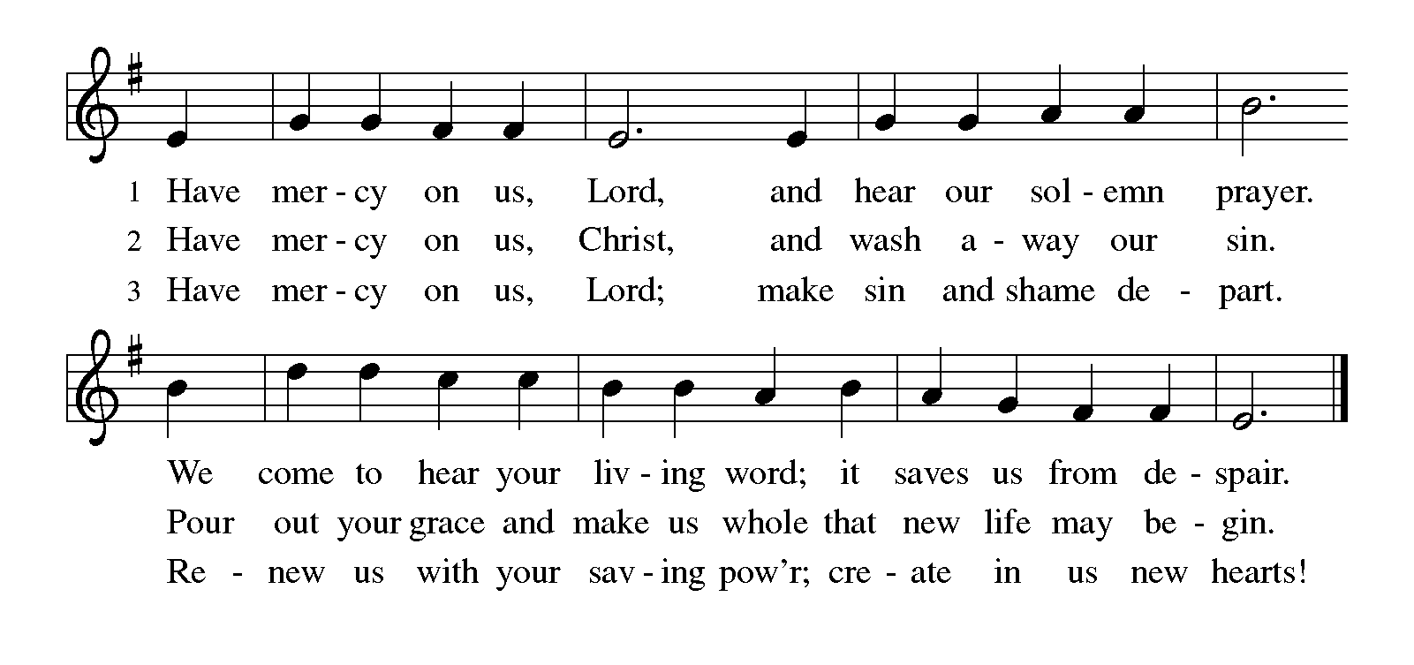
KYRIE
SONG OF PRAISE
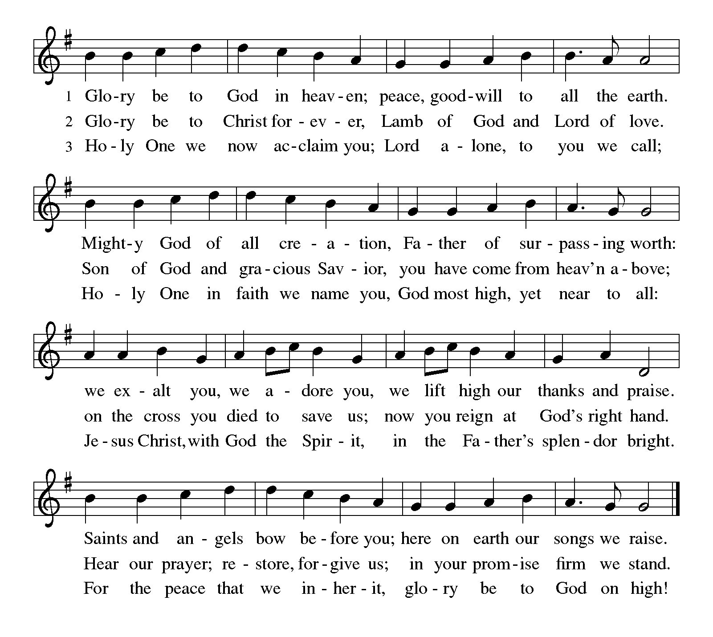

PRAYer of the Day together we pray:

Gracious God. So often when we hear testimony, even from those we know and trust, we doubt the truth of your presence in our lives. Forgive us for our stubborn shortsightedness, and open our hearts to recognize the truth of your love for us. In Jesus’ name we pray. Amen

PASSING OF THE PEACE

V May the peace of the Lord be with you always!
C And also with you
V Please generously share God’s peace all around!

WORSHIP CAROL

Ensemble “Jesus Is Coming Again”

LESSON: Acts 8:26-39

Then an angel of the Lord said to Philip, “Get up and go toward the south^{[a]} to the road that goes down from Jerusalem to Gaza.” (This is a wilderness road.) ²⁷ So he got up and went. Now there was an Ethiopian eunuch, a court official of the Candace, the queen of the Ethiopians, in charge of her entire treasury. He had come to Jerusalem to worship ²⁸ and was returning home; seated in his chariot, he was reading the prophet Isaiah. ²⁹ Then the Spirit said to Philip, “Go over to this chariot and join it.” ³⁰ So Philip ran up to it and heard him reading the prophet Isaiah. He asked, “Do you understand what you are reading?” ³¹ He replied, “How can I, unless someone guides me?” And he invited Philip to get in and sit beside him. ³² Now the passage of the scripture that he was reading was this:
“Like a sheep he was led to the slaughter, and like a lamb silent before its shearer, so he does not open his mouth. ³³ In his humiliation justice was denied him. Who can describe his generation? For his life is taken away from the earth.” ³⁴ The eunuch asked Philip, “About whom, may I ask you, does the prophet say this, about himself or about someone else?” ³⁵ Then Philip began to speak, and starting with this scripture he proclaimed to him the good news about Jesus. ³⁶ As they were going along the road, they came to some water, and the eunuch said, “Look, here is water! What is to prevent me from being baptized?”^{[b]} ³⁸ He commanded the chariot to stop, and both of them, Philip and the eunuch, went down into the water, and Philip^{[c]} baptized him. ³⁹ When they came up out of the water, the Spirit of the Lord snatched Philip away; the eunuch saw him no more and went on his way rejoicing.

GOSPEL ACCLAMATION
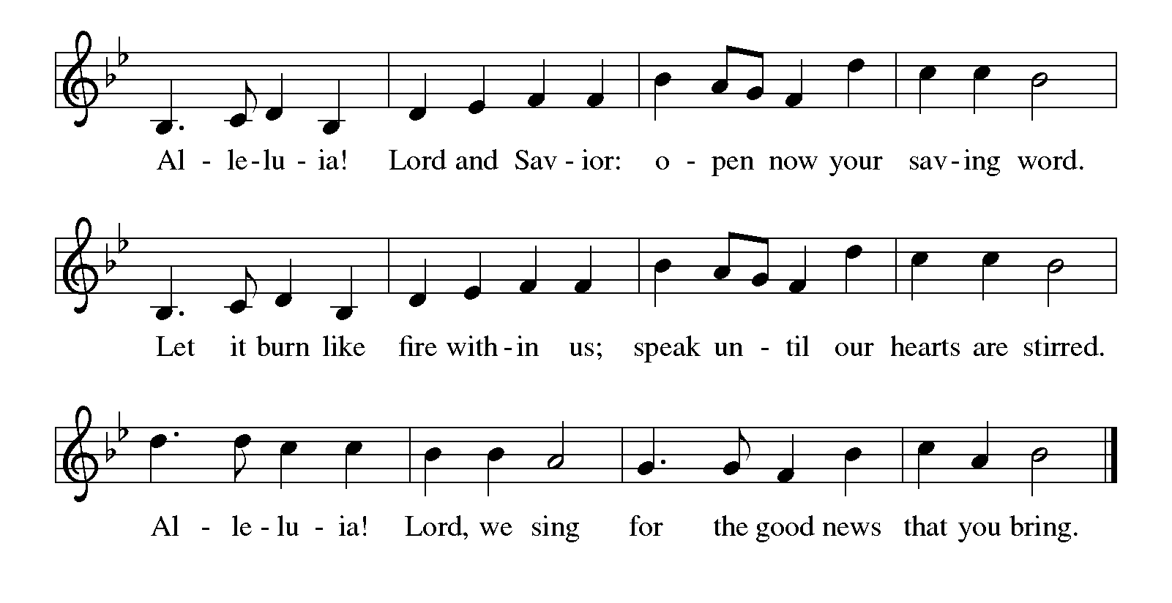

GOSPEL Luke 24:44-47
Then he said to them, “These are my words that I spoke to you while I was still with you—that everything written about me in the law of Moses, the prophets, and the psalms must be fulfilled.” ⁴⁵ Then he opened their minds to understand the scriptures, ⁴⁶ and he said to them, “Thus it is written, that the Messiah^{[a]} is^{[b]} to suffer and to rise from the dead on the third day ⁴⁷ and that repentance and forgiveness of sins is to be proclaimed in his name to all nations, beginning from Jerusalem.

V The Gospel of the Lord
C Praise to the Lord

TEACHING: “Willing Witnesses???!!” Vicar Judy Zeiss

HYMN OF THE DAY “Lift High The Cross” ELW 660

THE APOSTLES’ CREED
I believe in God, the Father almighty, creator of heaven and earth.
I believe in Jesus Christ, His only Son, our Lord.
He was conceived by the power of the Holy Spirit
and born of the virgin Mary.
He suffered under Pontius Pilate,
was crucified, died, and was buried.

He descended into hell.
On the third day He rose again.
He ascended into heaven,
and is seated at the right hand of the Father.
He will come again to judge the living and the dead.

I believe in the Holy Spirit,
the holy catholic Church,
the communion of saints,
the forgiveness of sins,
the resurrection of the body,
and the life everlasting. Amen.

PRAYERS OF INTERCESSION

V We pray for the church, the world, and all of creation.
A brief silence.
V Your creation fills us with joy and wonder, from mighty mountains and crashing oceans to trickling streams and the softest breezes. Give us a heart of the care and preservation of all that you have made. Holy and wonderful God;
C Hear our prayer.

V Be with students who are preparing for graduation. Relieve them of anxiety about final tests and the exciting but uncertain future. Bless them as they move toward this new chapter in their lives. Holy and wonderful God;

C Hear our prayer.

Here other petitions may be offered. Together we pray

C Bless Your Church. Purify, preserve & provide through your Holy Spirit. We pray for each of our mission congregations, local partners, and care ministries. We also pray for the congregation’s vision and call process. May we continue to work toward our mission and uphold our values while we support the call committee in moving toward a pastoral transition.
We also pray for that pastor whom God calls to Gloria de Cristo to work with us to move this congregation forward in mission. Enlarge our hearts toward people far from God while we “Walk with Jesus to bring new life and hope to every person.”

V Send healing and comfort to all who face uncertainty in regard to their health, whether physical, emotional, or spiritual, especially those we remember in our hearts. Holy and wonderful God;

C Hear our prayer.

V Be with those who are in times of transition of any kind – those moving, changing jobs, adjusting to divorce, and more. Help them know you are with them through everything going on in their lives, and give them patience and acceptance of whatever uncertainty they face. Holy and wonderful God;

C Hear our prayer.

V Thank you for the faithfulness of others whose lives, though over, still impact us today. May we follow their examples in our own daily living. Holy and wonderful God;
C Hear our prayer.

V These and the prayers of all creation we lift to you in Jesus’ name.

C Amen

THE OFFERING (For those watching there is a link for online giving in the description of the video. We are thankful for all the support from both in- person giving as well as online giving.)

QR CODE GIVING: Just use your smart phone’s QR Code Reader and scan this QR Code to begin your generosity giving! You can set it up to give your gift as a One-Time gift or you can set up a recurring gift (Every week, Every 2 weeks, 2X/month, (1st & 15th), Monthly, Quarterly, or Annually). You can have your gift taken directly from your bank account or your debit or credit card. You can pick the day you want your gift to be given. With this way of giving, you can also give to the General Offering, Church Property, World Hunger, and Lent/Holiday gifts. To view the different giving opportunities: When you first enter the app just scroll down to the line that says ‘View more giving opportunities’ below the ‘ways to give’ heading.

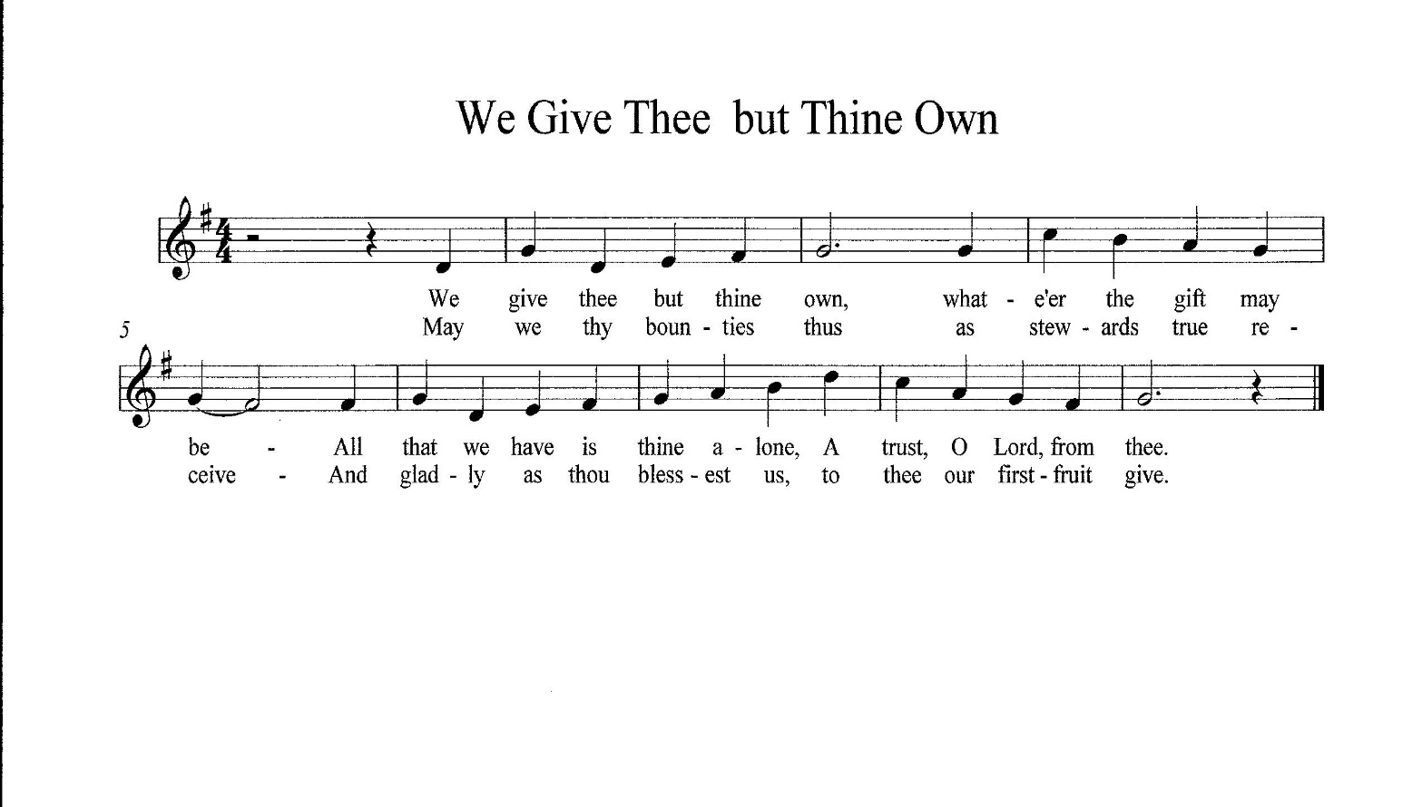
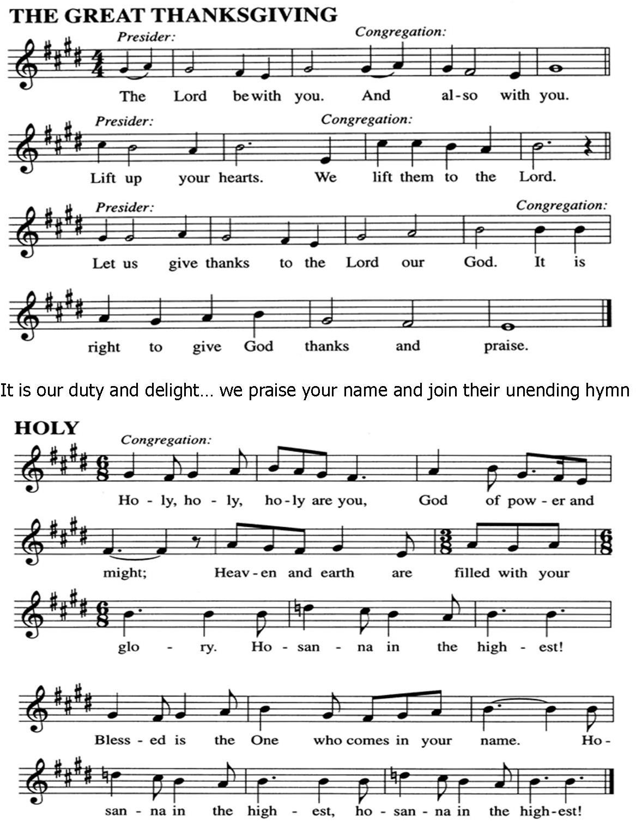
OFFERING RESPONSE (please stand)

THE GREAT THANKSGIVING

V The Lord be with you.
C And also with you.

V Lift up your hearts.
C We lift them to the Lord.

V Let us give thanks to the Lord our God.
C It is right to give our thanks and praise.

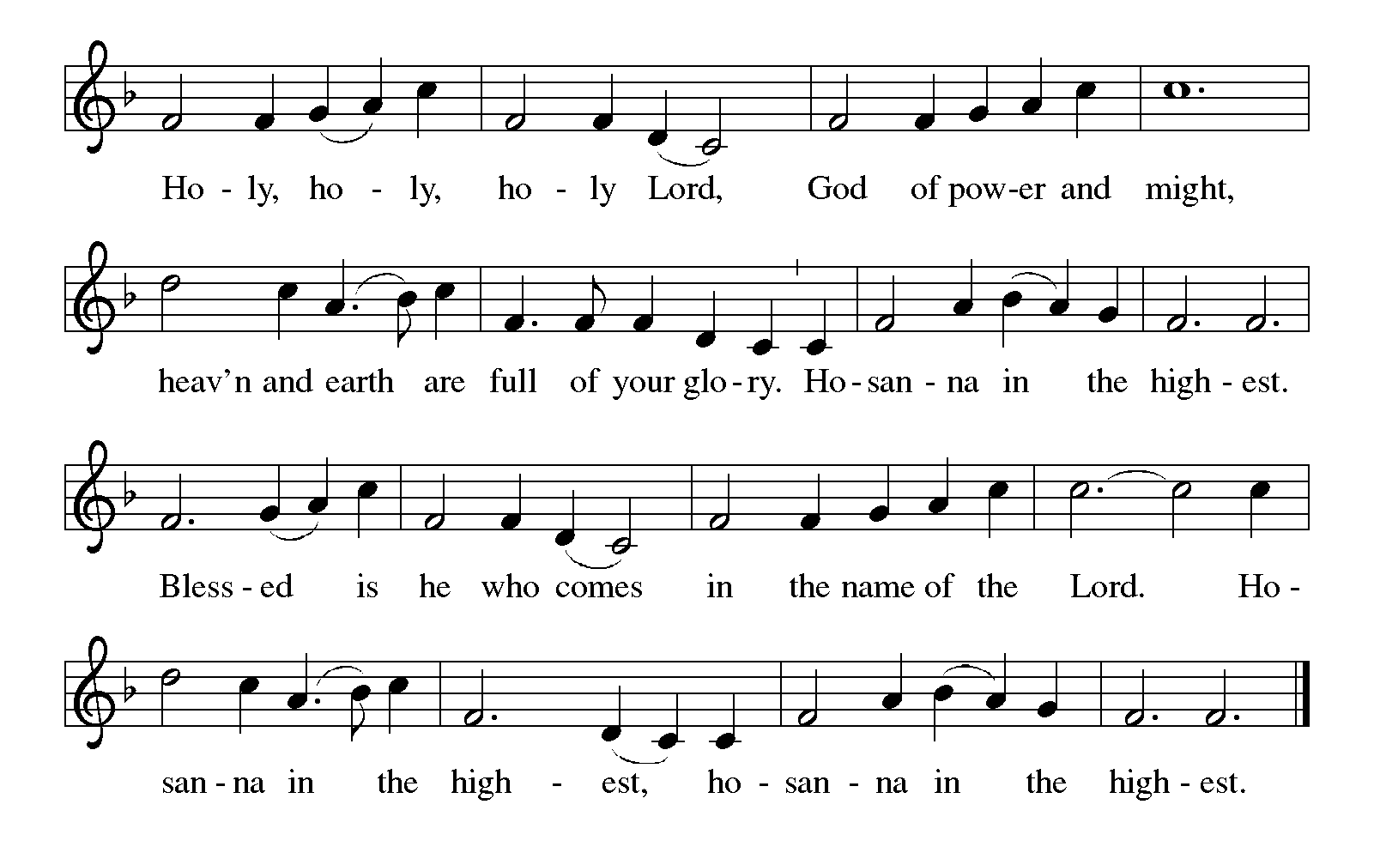
CONGREGATIONAL SUNG RESPONSE
V Blessed are you, Lord of heaven and earth. In mercy for our fallen world, you gave your only Son, that all those who believe in him should not perish, but have eternal life.
We give thanks to you for the salvation you have prepared for us through Jesus Christ.
Send now your Holy Spirit into our hearts, that we may receive our Lord with a living faith as he comes to us in his holy supper.
C Amen. Come, Lord Jesus.

THE SACRAMENT OF HOLY COMMUNION

WORDS OF INSTITUTION

Communion is open to all baptized believers who know Jesus as Savior and seek to live with him as Lord of all areas of life. You receive the wafer in your hand and choose from the individual cup of wine or white grape juice. Those who are not communing as well as children may come forward for a blessing. Simply cross your arms in front of your chest to receive a blessing. Everyone should complete a slip found in the pew rack and place it in the offering plate. Consider the options on reverse side as to how you may serve this congregation.

THE LORD’S PRAYER

C Our Father, who art in heaven, hallowed be Thy name, Thy kingdom come, Thy will be done, on earth as it is in heaven. Give us this day our daily bread; and forgive us our trespasses as we forgive those who trespass against us; and lead us not into temptation, but deliver us from evil. For thine is the kingdom, and the power, and the glory, forever and ever. Amen.
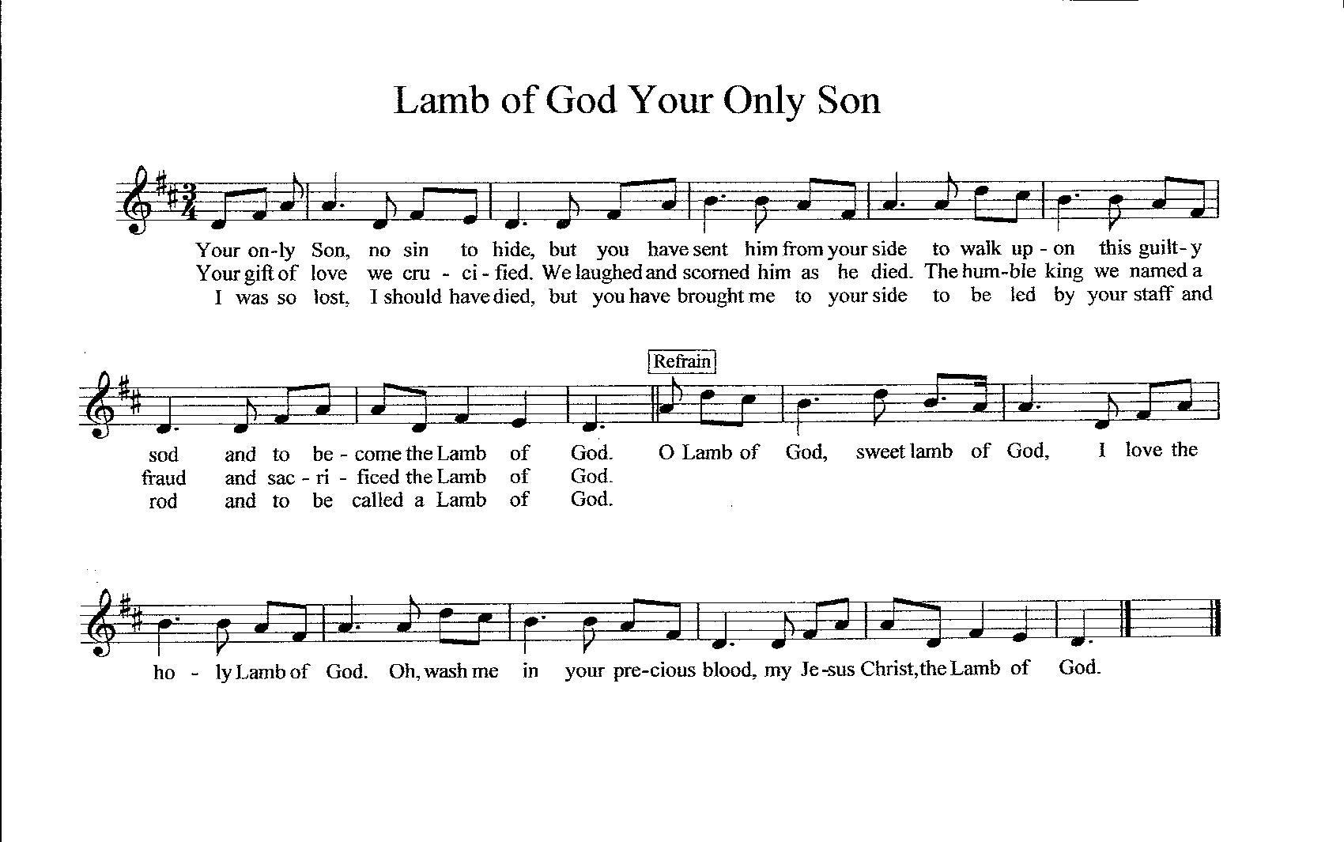
HYMNS DURING COMMUNION

“How Great Thou Art” ELW 856
“Amazing Grace, How Sweet the Sound” ELW 779
“What a Friend We Have in Jesus” ELW 742
POST COMMUNION BLESSING (please stand)

V The Body and Blood of our Lord and Savior Jesus Christ strengthen you and keep you safe in His Grace until everlasting life.
C Amen.

PRAYER AFTER COMMUNION (together we pray)

C God of steadfast love, at this table you gather your people into one body for the sake of the world. Send us in the power of your Spirit, that our lives bear witness to the love that has made us new in Jesus Christ, our Savior and Lord. Amen.

SENDING HYMN “This Little Light of Mine” ELW 677
V Almighty God has created you and has a purpose for your life every day! Lord, Help us remember, IF YOU ARE NOT DEAD...
C YOU ARE NOT DONE!

V Live your lives in Christ, rooted and built up in him, and abound in thanksgiving; and the blessing of the Holy Trinity, ☩ one God, be upon you and remain with you forever.
C Amen.

Dismissal

V Go in peace. Christ is sending you.
C Thanks be to God.

Sundays and Seasons.com Copyright 2008 Augsburg Fortress. All rights reserved. Reprinted by permission under Augsburg Fortress Liturgies Annual License #26302.
New Revised Standard Version Bible, copyright 1989, Division of Christian Education of the National Council of the Churches of Christ in the United States of America. Used by permission. All rights reserved.
Reprinted from Lutheran Book of Worship, copyright 1978 or reprinted from Service book and Hymnal, copyright 1958. Used by permission of Augsburg Fortress license #11751-L.
Reprinted from Evangelical Lutheran Worship, copyright 2006 Augsburg Fortress. Used by permission of Augsburg Fortress license #11752-E.
Cover page – Reprinted from Icon Two: Visual Images for Every Sunday, copyright 2004 Augsburg Fortress. Used by permission
CCLI Song #1527, Majesty, Hayford, Jack, copyright 1981, New Spring. For use solely with the SongSelect . Terms of Use. All rights reserved. CCLI License #132196

Announcements

REMEMBER: Those of you that leave Yuma for the summer, please note that on your green slip so that we can change your address to receive the monthly Evangel. Please give us your address, date leaving, and date of return. Thank You!!

ALSO: As you clean out your cupboards and pantries getting ready to go to your summer home, I would encourage you to pack up whatever you want to share, put it in a box marked “For Crossroads Mission” and bring them to the church. I will make sure that they get delivered to the Mission.

PRAYER FELLOWSHIP:
The first gathering of the Prayer Fellowship will be Thursday, May 15th at 9:00 am in the church Sanctuary. We are so looking forward to gathering together in love, through the power of the Holy Spirit, as did the early church as described in the Book of Act. We will lift up our church, our leaders, our congregation and ask to see God work in our call process to provide just the right pastor at just the right time.
Join our voices and hearts Thursday, May 15th! Pray and Watch the blessings flow!

GriefShare: A new session of GriefShare began on April 27st from 12:15—2:30 pm in the Fellowship Classroom. If you, or someone you know have lost a loved one and are struggling this is the place you might want to be. If you have any questions or concerns contact the church office at 928-342-6002.

REMINDERS:

Support Groups

GriefShare: Sundays at 12:15 pm, Fellowship Hall Classroom

Care Givers Lunch: Every Friday at 12:30 pm. Contact Sandy Timm for the location.

Service
Monthly Potluck 1st Sunday of each month following worship in Fellowship Hall. Bring your favorite dish to share and come for fellowship.

Food Pantry: 1st Sunday of each month we collect food for the local Food Pantry. When doing your shopping consider picking up a couple of items to bring and donate.

Men’s Breakfast the 1st Saturday of each month, 8 am at Daybreakers. All gentlemen of the congregation are invited to come.

Women’s Breakfast Club 1st Saturday of each month, 8 am at Izzy’s on Foothills Blvd. All ladies of the congregation are welcome to attend.

Days for Girls: Check the calendar for the next date. Come join us for fellowship and fun.

Reading and Learning

Bible Study: Mondays, 12:30 pm, Fellowship Classroom (Gospel of Luke)

Fun and Fellowship

Line dancing: Wednesdays at 10:00 am in Fellowship Hall

Chair Aerobics : Classes are held every Wednesday at 1 pm & Fridays at 10:30 am in Fellowship Hall. A donation of $5/session is appreciated to offset the cost of the instructor. Everyone is welcome.

WORSHIP ASSISTANTS
Service time is: 8:30 am

Dat | Altar | Ushers | Greeter/Comm. | Readers | AV
5/11 | Joanne | S. Arceneaux/L.Layton | Roger/Jen Krough | Anna Stokes | Char/Dave
5/18 | Niki | Jay/Anna Stokes | Larry Unger/C. Wade | S. Arceneaux | Mich/Gary
5/25 | Char | Chuck/Mona O’Reilly | Dave/N. Griffiths | Jeanie Volpe | Mich/Tom
6/1 | Joanne | Dave/Marge Graham | Ted/Niki Duffy | S. Weidling | Char/Dave
6/8 | Jan | Sandy Everly/Lisa Crayne | Bob/Judy Zeiss | C. Wertman | Mich/Tom
6/15 | Joanne | T Martin/J. Hollandsworth | Chuck/Mona O’Reilly | Michelle | Char/Tom
6/22 | Niki | Brenda Taylor/L. Unger | C. Wade/Jan Klipfel | Jean Gerfen | Mich/Dave
6/29 | Char | Rick/Barbara Sherwood | Dave/Marge Graham | S. Arceneaux | Char/Dave
7/6 | Char | John/Verna Arnold | Bob/Judy Zeiss | Char | Mich/Dave

Attendance for May 4
114 @ 8:30 am

CALENDAR FOR THE COMING WEEK

DATE | TIME | ACTIVITY | LOCATION
Monday 5/12 | 9:00 am | Glorious Quilters | Fellowship Hall
Monday 5/12 | 12:30 pm | Bible Study on Luke | Fellowship Classroom
Tuesday 5/13 | 7:00 am | TOPS | Fellowship Classroom
Wed. 5/14 | 10:00 am | Line dance exercise | Fellowship Hall
Wed. 5/14 | 1:00 pm | Chair Aerobics | Fellowship Hall
Wed 5/14 | 4:45 pm | Bells of Glory | Sanctuary
Wed. 5/14 | 6:45 pm | Choir Rehearsal | Sanctuary
Thurs. 5/15 | 7:00 am | TOPS | Classroom
Thurs. 5/15 | 9:00 am | Prayer Fellowship | Sanctuary
Friday 5/16 | 8:00 am | TOPS | Fellowship Hall
Friday 5/16 | 10:30 am | Chair Aerobics | Fellowship Hall
Friday 5/16 | 10:30 am | Spanish/English Conversation | Fellowship Classroom
Friday 5/16 | 12:30 am | Caregivers Lunch | Contact Office
Saturday 5/17 | 9:00 am | TOPS | Fellowship Classroom
Sunday 5/18 | 8:30 am | Worship/Communion | Sanctuary
Sunday 5/18 | 12:15 pm | GriefShare | Fellowship Classroom

GLORIA DE CRISTO LUTHERAN CHURCH
11273 E. 40th Street
Yuma, AZ 85367

Phone:(928) 342-6002 Fax (928) 342-7613

Website: www.gloriadecristo.com

Authorized Vicars:
Dr. Shirley Ehler Jerry Randby
Char Schomisch Paula Pegues
Judy Zeiss

Minister of Worship, Organist & Choir Director: Dr. Shirley Ehler
Pianists: Marie Ritten, Lorie Rapp, Pam Carter, Suzanne Haggett
Bells of Glory: Lorie Rapp
Violin: Ami Gudjohnsen

Stephen Ministry Leaders:
Jim Wehrer Michelle Cegon Sherrie Wehrer Niki Duffy
Sandy Corless Robin Marlatt

GriefShare Leaders:
Ted & Niki Duffy
Lisa Crayne
Mary Marsh

Office Staff:
Char Schomisch, Secretary



Follow us on Facebook and subscribe to our YouTube channel
Links to both pages can be found on our

